**CP2013** ASSESSMENT TASK: **Project Part-2**

This assessment task has been prepared by Dr. Dmitry Konovalov for James Cook University.  Updated 4 September 2014.

**© Copyright 2014**

This publication is copyright. Apart from any fair dealing for the purpose of private study, research, criticism, or review as permitted under the Copyright Act, no part may be reproduced by any process or placed in computer memory without written permission.

**ASSESSMENT TASK DESCRIPTION**

This task is the Audit of project deliverables in terms of quality, quantity, complexity and project management, and also ***individual contribution*** to the overall team effort. In terms of the Agile Software development, this is the ***iteration-2***. It delivers the ***alpha release*** to the client.

Your instructor may ask you to provide a paper copy of this assignment. Depending on the class size, campus or timetable circumstances, it could be more appropriate/convenient/efficient to mark the hard copy rather than electronic version of this assignment.

**[Total awarded _____ out of 100 marks] ASSESSMENT TASK CRITERIA SHEET**

The following is the list of items which are required to be completed in this assignment. Maximum possible marks are given in brackets at the beginning of each item.

**[_____/5 marks] Assignment is done in a group with 3-5 students.** Individual Team Feedback form is submitted to LearnJCU electronically. One submission per student.

Write group members here:

Student Name-1, Project role(s), specific ***individual*** contributions to this assessment item:

Zoe McIntosh: JavaScript/HTML/MySQL Programming zoe.mcintosh@my.jcu.edu.au

Steven Marks: Java/MySQL Programming steven.marks1@my.jcu.edu.au.

Daniel White: JavaScript/HTML/MySQL Programming daniel.white1@my.jcu.edu.au.  
Adam McCormick: Java/MySQL Programming adam.mccormick@my.jcu.edu.au

Note: Each student ***must be present*** at the audit, and must be ready to answer any questions regarding the student’s individual contribution.

**[_____/5 marks] Assignment is completed using electronic copy of *this* document (available from LearnJCU).**

**Assignment (*this* filled out document) is submitted to LearnJCU electronically.** One submission per team.

**[_____/50 marks] Report *ACTUALLY* delivered alpha-release (see your user stories in iteration-1).  Any deviations from the plan for alpha-release must be documented and briefly explained.** Write here: Minimum **ONE** page, maximum **THREE** pages.

·         [____/10 marks] Demonstrate delivered alpha-release;

Website is located at www.uberthug.com/wordpress with downloadable JAR file located on this site from the Download tab on the main page.

·         [____/10 marks] Quality, acceptance testing, how well the user stories are implemented;

The website and Java edition both contain a number of automated entries for proof of concept and proof of task for the user stories. Each function was tested against the user story for completeness of comparison between function and user story.

·         [____/10 marks] Complexity, technical competence, appropriate ICT solution/languages/tools;

We believe that the operation of the program with either form of the project is complete. We have used the user stories to determine our correct functionality and we have used the elements described below to build and publish the elements of the project according to agile practices.

·         [____/10 marks] Client satisfaction and feedback:

We acted as the client for testing and we were more than satisfied that the elements described by the user stories were completed and proven to operate correctly.

User Stories:

|  |  |  |
| --- | --- | --- |
| Number | User Story | Time Allocated |
| US001 | Admin Can Add A New Employee | 10 |
| US002 | Admin Can Delete An Employee | 5 |
| US003 | Admin Edit Employee Details | 15 |
| US004 | Admin Can Post a Timecard | 15 |
| US005 | Admin Can Post a Sales Commission Timecard | 10 |
| US006 | Admin Can Change Commission percentage | 5 |
| US007 | Admin Can Select Union Membership per Employee | 10 |
| US008 | Admin Can Change Employees Payment Method | 15 |
| US009 | Admin Can Change Employees Unions Due Amount | 5 |
| US010 | Admin Runs the payroll for the day including pay disbursement. | 10 |

Changes to the user stories: Admin is the only user, for both the website and java program. We worked with the understanding that the Admin user will be the one adding the time cards into the system, not the user. The admin is the only one in control of the program.

Another User Story added: Testing the Daily payroll. For the purpose of the software, we need to test that it can be run every day. Testing dates and days to confirm the three types of possible pay run.

Another User Story added: Admin can post sales receipt

 [____/10 marks] ***Burn-down chart***.

|  |  |  |  |  |  |  |  |
| --- | --- | --- | --- | --- | --- | --- | --- |
|  | Burn Down Chart |  |  |  |  |  |  |
| Number | User Story | Time Allocated | Week 5 | Week 7 | Week 9 | Week 11 | Week 13 |
| US001 | Admin Can Add A New Employee | 10 |  |  |  |  |  |
| US002 | Admin Can Delete An Employee | 5 |  |  |  |  |  |
| US003 | Admin Edit Employee Details | 15 |  |  |  |  |  |
| US004 | Admin Can Post a Timecard | 15 |  |  |  |  |  |
| US005 | Admin Can Post a Sales Commission Timecard | 10 |  |  |  |  |  |
| US006 | Admin Can Change Commision percentage | 5 |  |  |  |  |  |
| US007 | Admin Can Select Union Membership per Employee | 10 |  |  |  |  |  |
| US008 | Admin Can Change Employees Payment Method | 15 |  |  |  |  |  |
| US009 | Admin Can Change Employees Unions Due Amount | 5 |  |  |  |  |  |
| US010 | Admin Runs the payroll for the day including pay disbursement. | 10 |  |  |  |  | Complete |

**[_____/10 marks] One example of SRP, OCP, LSP, DIP, ISP [in code and diagram];**

Single Responsible Principle, Open Close Principle:

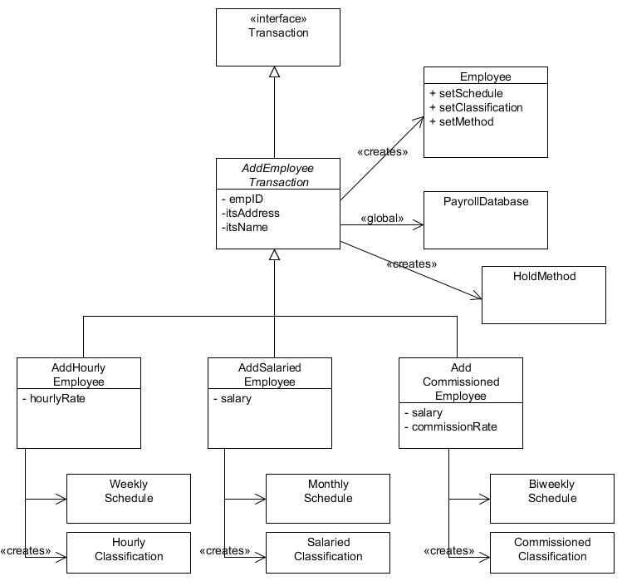

Interface Segregation Principle - Business logic is segregated out via multiple controllers which implement ActionListener:

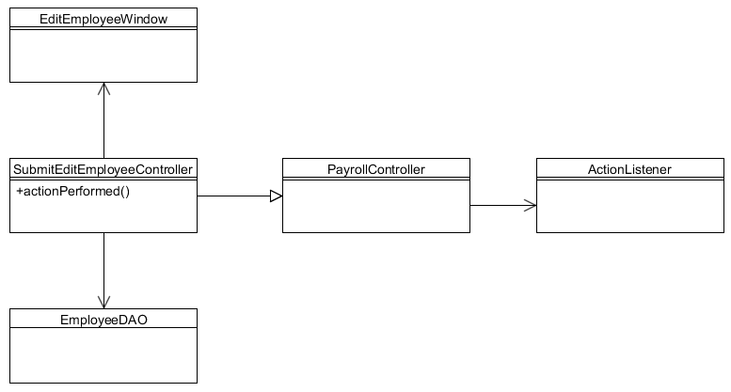  
  
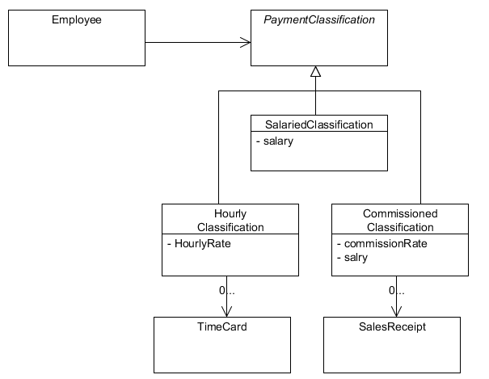  
  
**[_____/10 marks] One example of Command, Template, Facade, Singleton, Factory patterns [in code and diagram].**

Command pattern - AddEmployeeTransaction

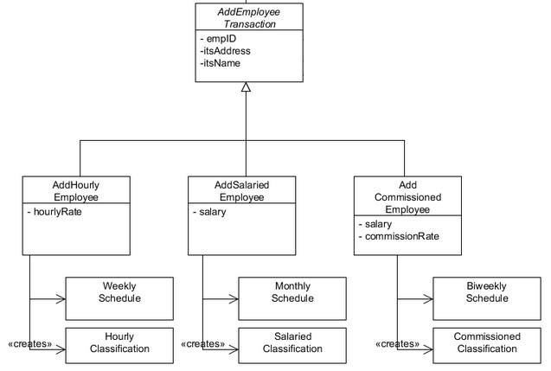

Template pattern – Model View Presenter, Run Application

  
  
  
  
  
  
  
  
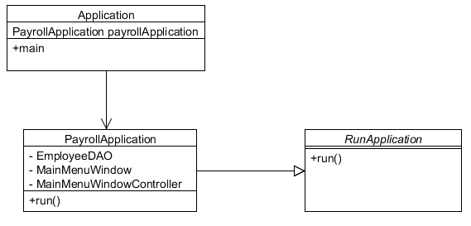  
  
Facade-EmployeeDAO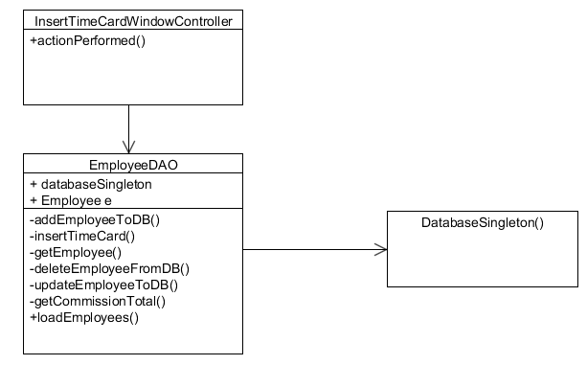

Singleton - For creating the connection to the Database:.

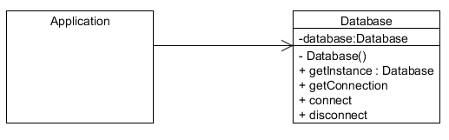

Factory pattern - Substitute factory for creating employees and timecards: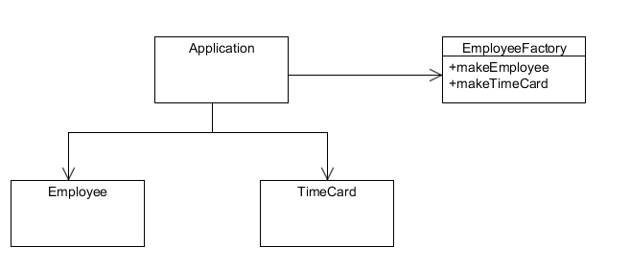

**[_____/10 marks] *Detailed design* for ICT-technical audience.** Write here: minimum **TWO** pages, maximum **FIVE** pages. ***Explain*** key design features of your system.  Use at least one example of the UML class, module-dependency, state, activity, sequence diagrams;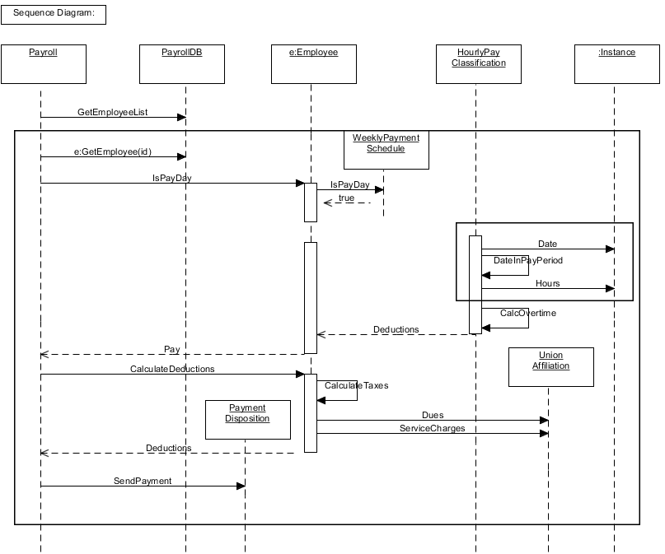

The system is designed to operate over two separate platforms for the Admin user. The Java platform and Wordpress system have been offered for flexibility and to enable the administrator to use the system on the platform for which they feel most comfortable. The system design enables the flexibility of expansion due to the following of agile design principles and the adherence to these practices.

In accordance to the user stories we have ensured that the system performs each of the required elements. Factors such as the able to call and edit by either employee or by day are functional.

**[_____/5 marks] *Demonstrate* the actual Project development ICT infrastructure.** This must include development environment, programming languages, source code repositories, project TESTING, collaboration tools, and development tools. Write here: minimum **ONE** page, maximum **TWO** pages.

·         [___/1 marks] **Configuration Management**/version control, e.g. git, github, heroku, bitbucket;

·         [___/1 marks] **Programming language**/IDE, e.g. php/WebStorm, java/IntelliJ;

·         [___/1 marks] **Testing** tools, data and procedures (what and how you ***actually*** do the testing), e.g. junit;

·         [___/1 marks] **Project Building** tools, e.g. how to set-up your development environment for a new team member;

Configuration Management:

GitHub was used for the version control for the Java application. In addition local development required the use of local storage for when access was not available. The Wordpress site was used as the version control for the development and GitHub used to backup the files as well as local copies stored.

Programming Language:

Java development occurred under Eclipse due to availability on the University systems. Wordpress functionality was used to create and modify the required elements within the Wordpress site. No secondary IDE is required for this operation.

Testing:

Unit testing with JUnit were undertaken for the Java code. With Wordpress the testing is manual and so a manual run of performance and result meters was established to confirm performance.

New Team Member;

*Instructions to Download and Install Java SDK.*

1. Go to this link: http://www.oracle.com/technetwork/java/javase/downloads/index.html and download the JAVA SE. Find and click the button that says, “Java Download”and click it.
2. Go to the section that says, “Java SE Development Kit 8u20”, accept the license agreement and select the correct version for your operating system.  e.g for a Win7 64bit OS the download link should be jdk-8u20-windows-x64.exe
3. Once this has downloaded, install it.

*Instructions to Download and Install Eclipse IDE.*

1. Go to this link: https://www.eclipse.org/downloads/
2. Find the section that says, Eclipse IDE for Java Developers
3. Download the version for your Operating system
4. Once it has downloaded, install it on your computer

*New team members are to review the documents located on the Google Drive Shared project folder.*

*Instructions to access the website*

We have a server for the development and presentation environment of the project.

The clients site is uberthug.com/wordpress

The login for the wordpress site is

username: makatak88

password: adam88

*Instructions to use Github*

1. Access the Git Hub account for this project by making a personal account at github.com and serach for the repository CP2013v2.
2. A Github GUI can be downloaded from the github site if you are not comfortable with terminal. https://windows.github.com/ or https://mac.github.com/
3. Get the current Java release from the repository  CP2013.

·         [___/1 marks] Something specific to your project and not covered by the above.

We utilised the wordpress theme “ZeeVision” and hosted the project on its own non-commercial server.

**[_____/5 marks] *Demonstrate* the actual Project release ICT infrastructure.**   
All ICT infrastructure required for the alpha-release must be in place. For example, deployment tools, external server/hosting, domain names. It is not acceptable to have identical development and release/production infrastructures. Write here: minimum **ONE** page, maximum **TWO** pages.

[___/1 marks] **Release building** tools/procedures, e.g. git-push to heroku;

The website is currently live and accessible as per the login instructions below.

The clients site is uberthug.com

The login for the wordpress site is:

username: makatak88

password: adam88

This is temporarily bypassed for the demonstration.

The release is live on our current server and the associated Java JAR file is available at this location.

[___/1 marks] **Client testing** and access to release, e.g. domain name, domain hosting; **Client training document, and procedures**;

Email to Client with Instructions;

Hello Client,

Instructions to download Payroll Desktop App Program:

1) Go to: [www.uberthug.com](http://www.2gether.com.au)/wordpress,

2) On the menu bar at the top of the page, click the light blue, Downloads tab link. On this page you have a clickable link reading “Download Java Payroll App here”.

3) The file will prompt to download and on completion, run this file. It will prompt a warning that is standard for all executable files, click the keep button and the application will launch.

3. a) If the dialog fails, right click the link on the page and press save as - You may need to select a folder to download the file into. You can do this when the window opens prompting you to do so. It is usually easiest to save the file to your desktop.

Thankyou,

XYZ Payroll Development Team

 [___/1 marks] **Release testing** tools, data and procedures (what and how you are planning to test);

Release testing tools are incorporated into our current releases. You are able to manually run active demonstrations of each activity and observe the confirmation of each function.

 [___/**2** marks] Something specific to your project and not covered by the above:

We included the ability to create a test database of employees for sampling the functionality of the product. Once this is run in Java the data is available for both the Java and Web solutions for demonstration and testing.